

**LAB # 4**



**DATED:**

**1st November, 2022**

**SUBMITTED TO:**

**Engr. Rehmat Ullah**

**CSE-202L Digital Logic Design Lab**

**Fall 2022**

**SUBMITTED BY:**

**Ali Asghar(21PWCSE2059)**

**Suleman Shah(21PWCSE1983)**

**Abu Bakar(21PWCSE2004)**

**Department of Computer Systems Engineering**

**University of Engineering & Technology, Peshawar**

UNIVERSAL GATES

OBJECTIVE:

* To study the realization of basic gates using universal gates (NAND & NOR)

COMPONENTS:

* IC’s
  + 7400 Quad-2-Input NAND Gate
  + 7402 Quad-2-Input NOR Gate
* LED’s
* Dip Switch
* 1KΩ Resistors

THEORY:

* AND, OR, NOT are called basic gates as their logical operation cannot be simplified further.
* NAND and NOR are called universal gates as using only NAND or only NOR any logic function can be implemented. Using NAND and NOR gates and De-Morgan's Theorems different basic gates & EX-OR gates are realized.

PROCEDURE:

1. Give biasing to the IC and do necessary connections as shown in the circuit diagram.
2. Give various combinations of inputs and note down output using LED.
3. Repeat the procedure for all gates.

|  |  |  |
| --- | --- | --- |
| **A** | **B** | **Y** |
| 0 | 0 |  |
| 0 | 1 |  |
| 1 | 0 |  |
| 1 | 1 |  |

**OBSERVATION TABLE**

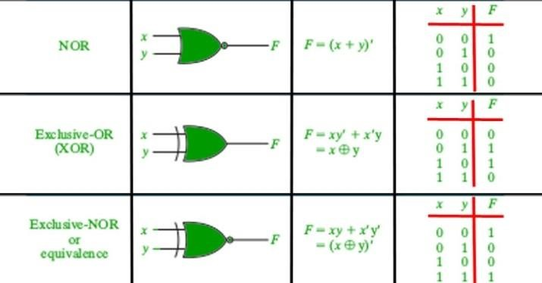

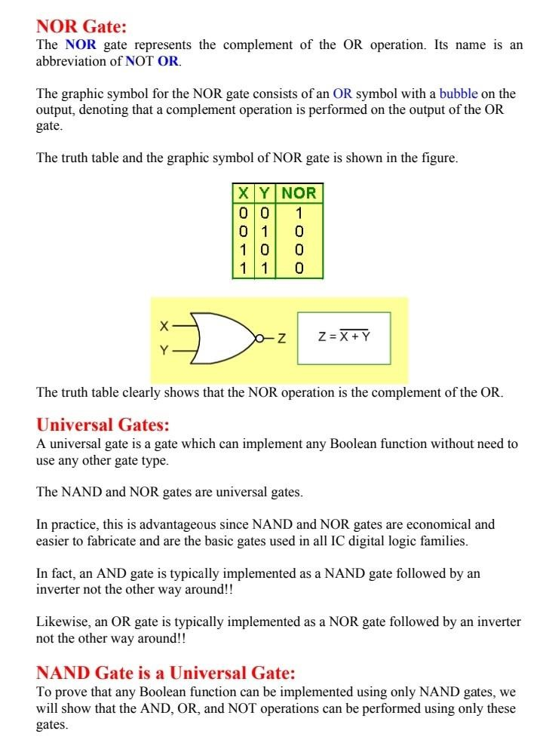

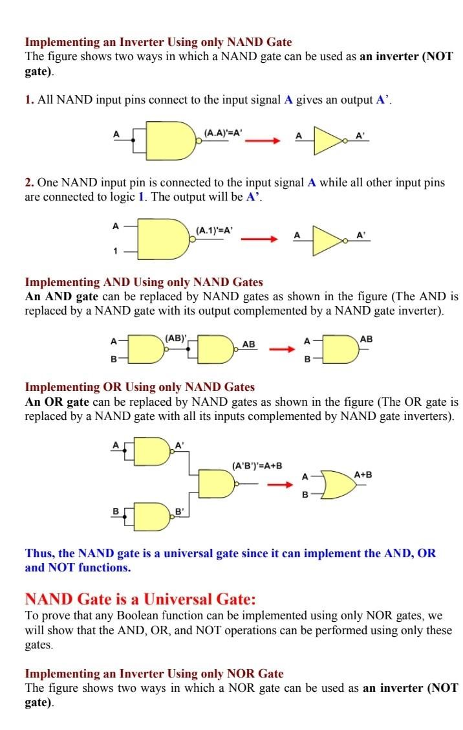

LAB WORK:

IMPLEMENTING XOR AND XNOR

USING NAND: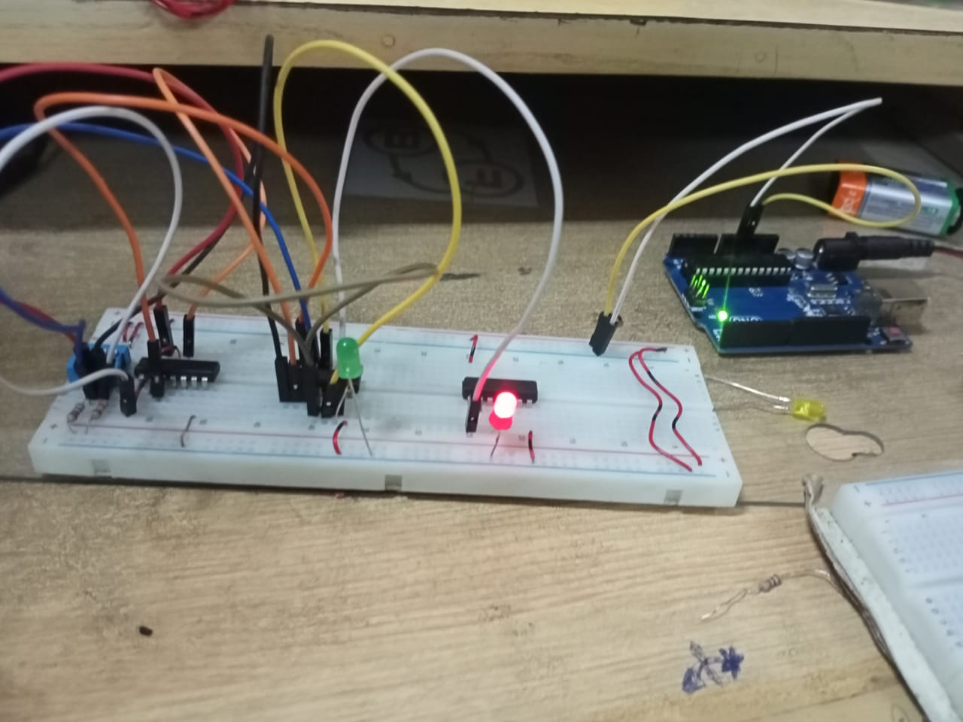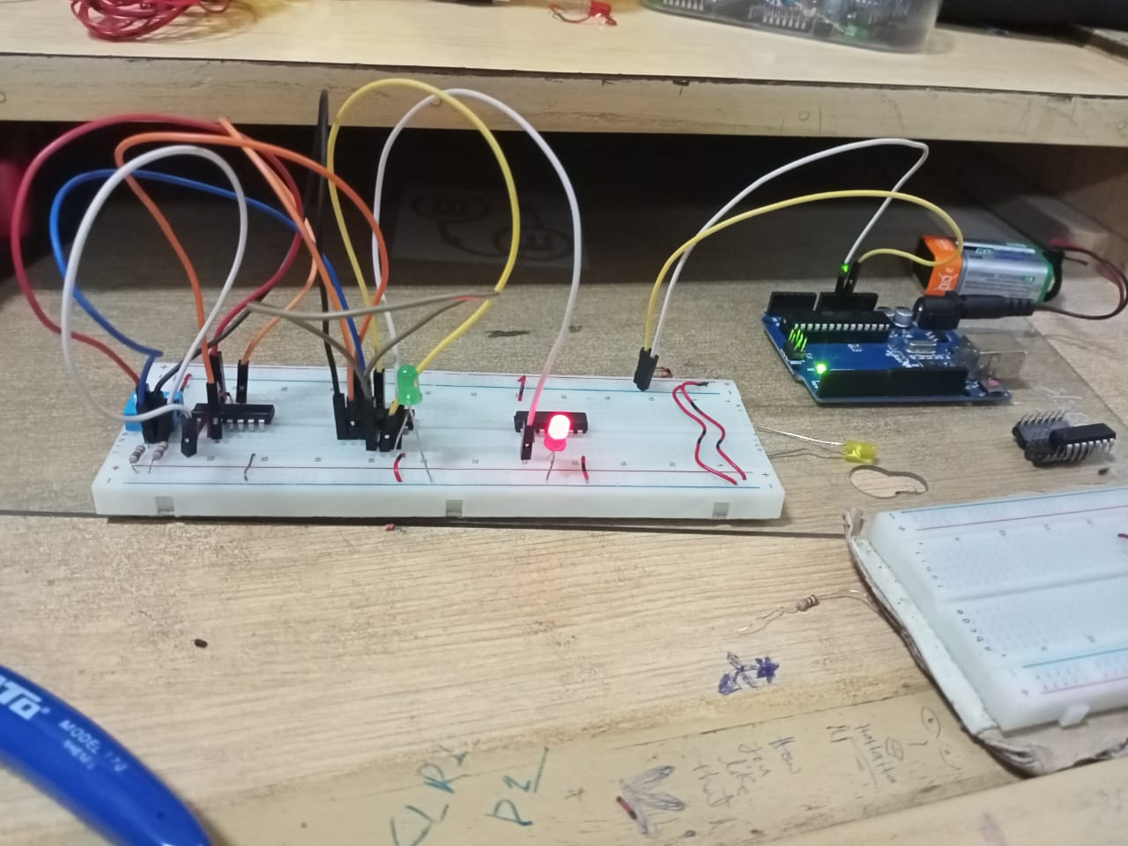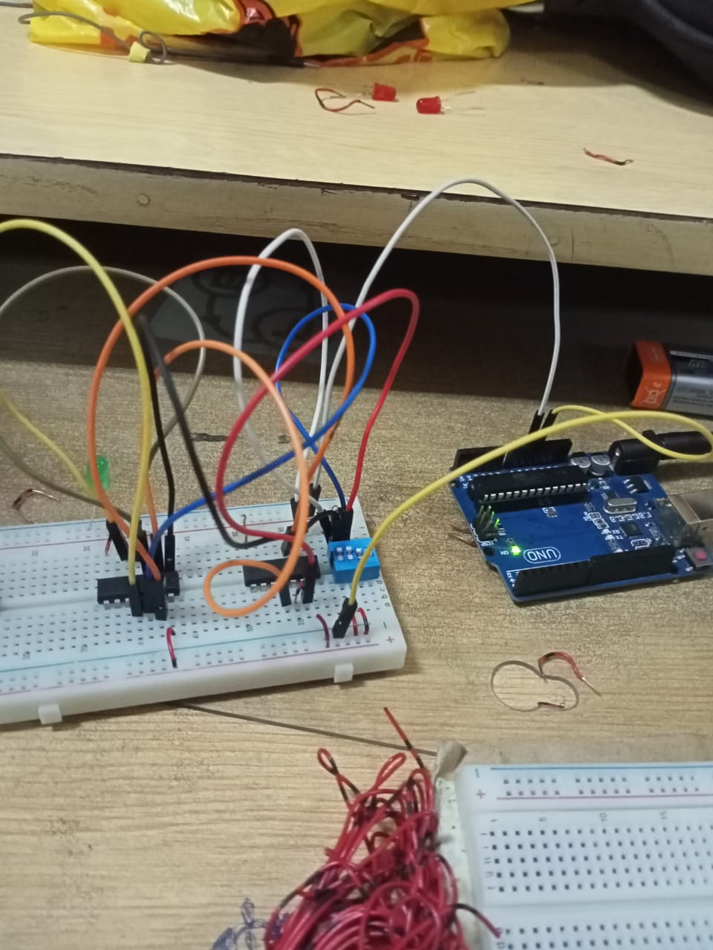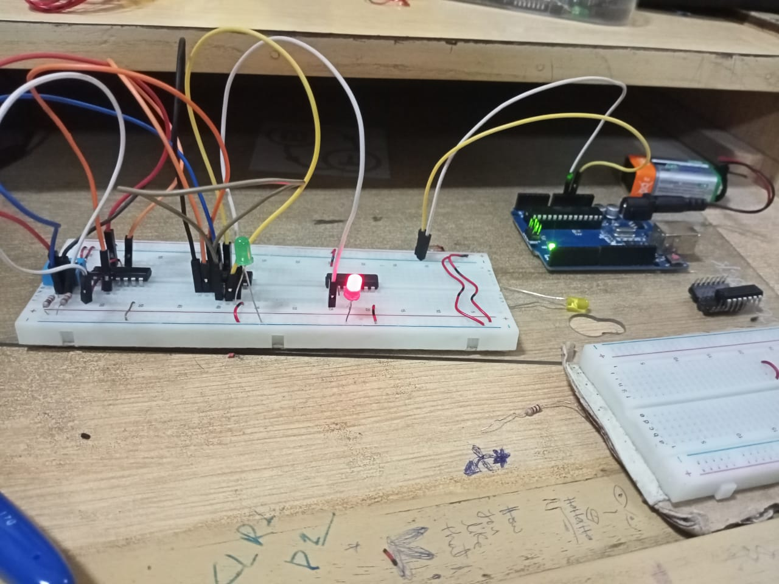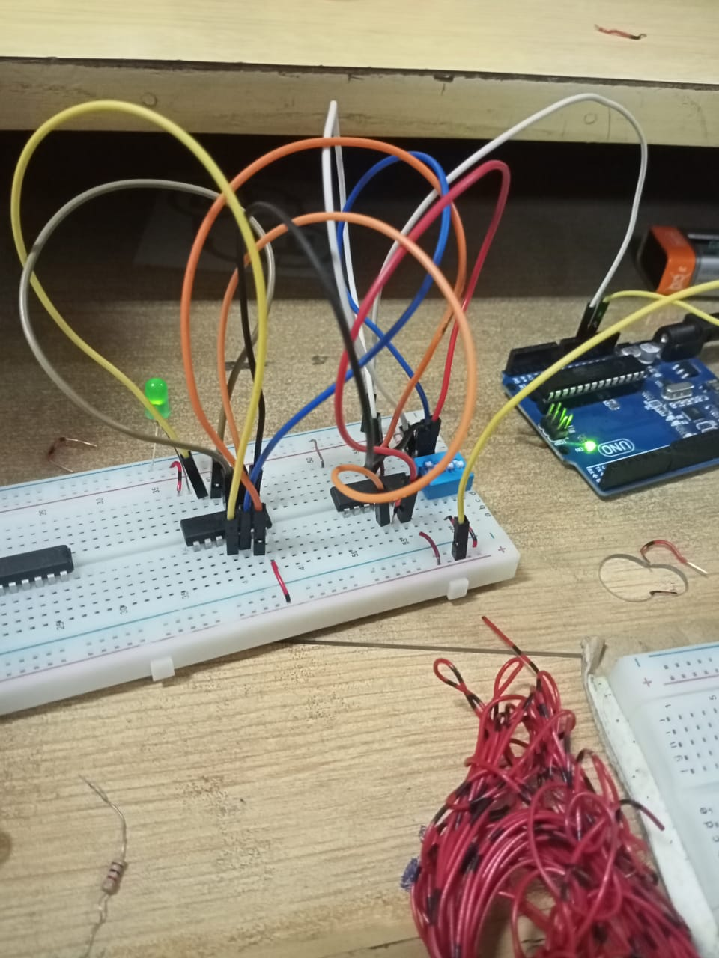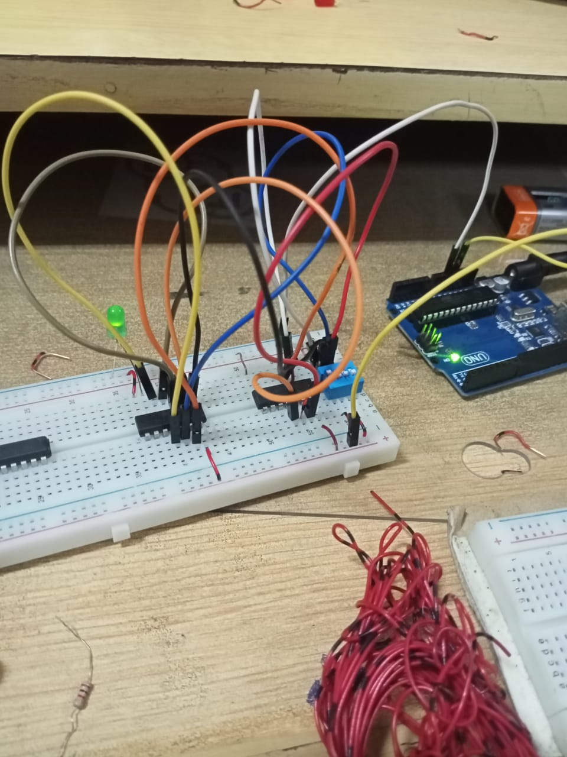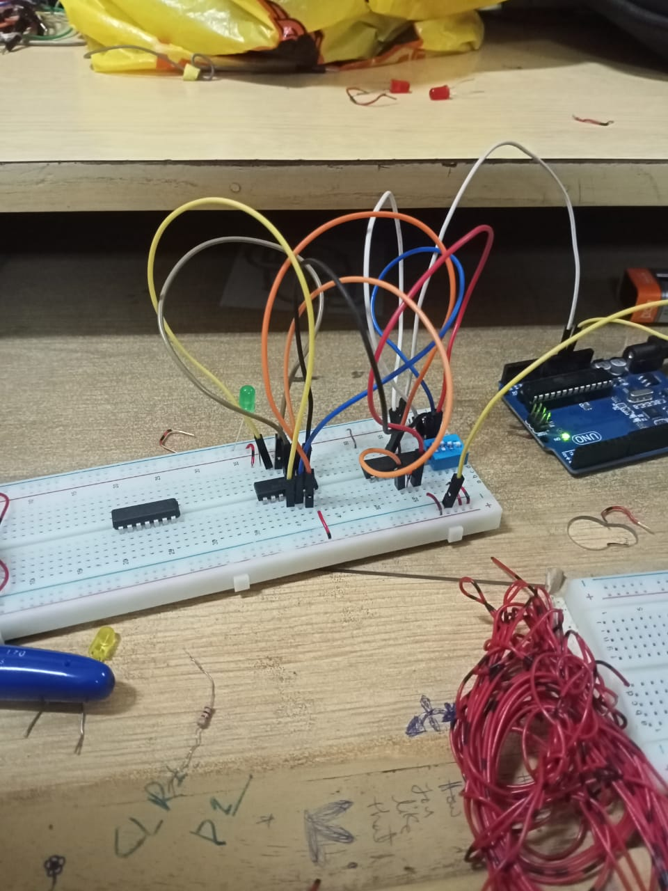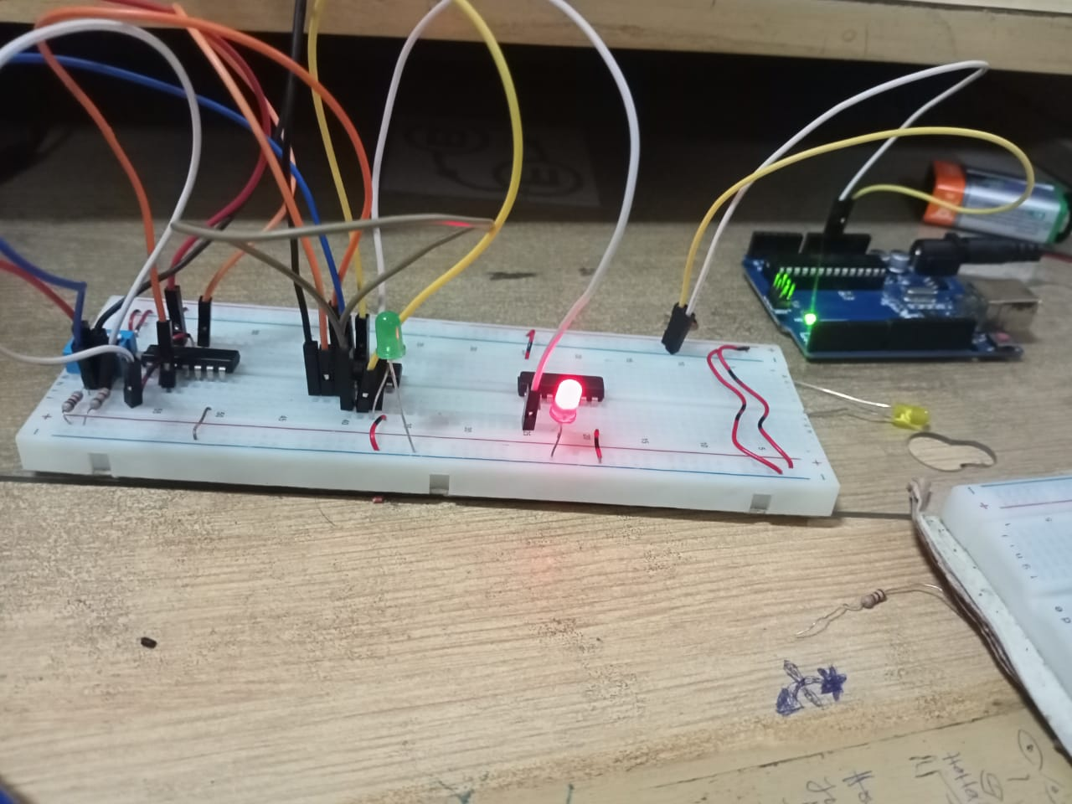

## USING NOR:

LAB READINGS:

Truth Table 3.1

|  |  |  |  |
| --- | --- | --- | --- |
| X | Y | XOR | XNOR |
| 0 | 0 | 0 | 1 |
| 0 | 1 | 1 | 0 |
| 1 | 0 | 1 | 0 |
| 1 | 1 | 0 | 1 |

CONCLUSION:

Thus, universal gates are studied.